Hospital Committee of Ahmedabad Municipal Corporation
Visited at AMC Dental College & Hospital

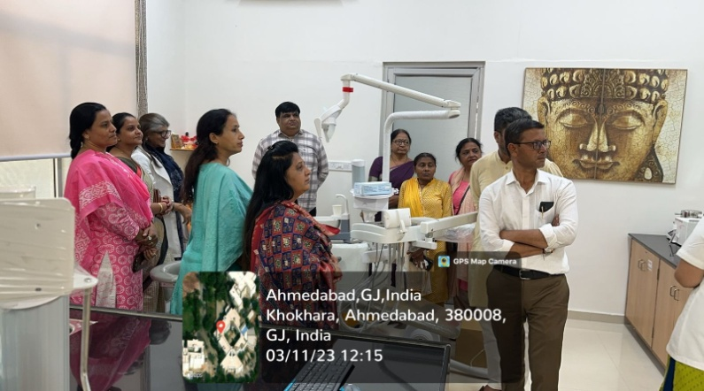
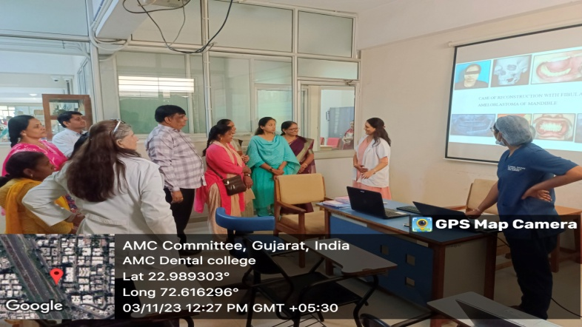
The Hospital Committee of Ahmedabad Municipal Corporation headed b the Chariman Shri Pareshbhai Patel along with his team visited AMC Dental College and Hospital on 03.11.2023. The hospital committee team visited SPS Clinic, Store, Labs, lecture halls & Auditorium of the college & Hospital. They were briefed and informed about various facilities available by the Dean Dr. Dolly Patel. The hospital committee team aslo visited different departments of the hospital and were informed about the facilities and patient care of the department by head of the department. They were extremely happy to understand various treatment procedures patient care and facilities provided to the public and appreciated the efforts taken to maintain the high standard & quality of care.

