Dr. Chirag Rudakia
Co-ordinator
Cover2Cover Club

To
The Dean
AMC Dental College and hospital.
Ahmedabad.

Subject: Permission to conduct “MIND HYGIENE PROGRAM 2.0”
Respected Ma’am,
I , undersigned, kindly request you to grant permission to conduct MIND BHYGIENE PROGRAM 2.0 on 20th March 2024 from 9:15 a.m. to 10:30 a.m. This program is conducted to create awareness among students and faculty about mental health and well being. This years’ program will emphasise more on social media and its implications on the youth.
We have invited, Dr. Jyotik Bhachech as a guest speaker for delivering lecture on the above mentioned topic.
Kindly grant us permission to avail Auditorium for the program. I hereby request you to grant permission to students and faculty to attend the program.
Thanking you.
Yours respectfully

Dr. Chirag Rudakia

Dr. Chirag Rudakia
Co-ordinator
Cover2Cover Club
Date: 9/4/2024

To
The Dean
AMC Dental College and hospital.
Ahmedabad.

Subject: Permission to conduct “OPEN MIC 4.0”
Respected Ma’am,
I , undersigned, kindly request you to grant permission to conduct OPEN MIC 4.0 on 18th April 2024 from 2 p.m. to 5 p.m. This program is conducted to provide platform to students to showcase skills in literature, poetry, storytelling, etc. This years’ program is part of annual extra mural activity conducted yearly.
Kindly grant us permission to avail Auditorium for the program. I hereby request you to grant permission to students and faculty to attend the program.
Thanking you.
Yours respectfully

Dr. Chirag Rudakia

PROGRAM REPORT
Name of the program: Mind Hygiene 2.0
Category: Extra Mural activity
Date: 20/3/2024
Speaker: Dr. Jyotik Bhachech (M.B.B.S, D.P.M)
No. of Participants: 342
Program Co-ordinator:

Report: With the current age of Smart phones, screens and Artificial intelligence, it is imperative to understand that we delve into the behavioural changes in the students on addiction or over usage of mobile.
In a very interactive manner, Dr Jyotik Bhachech highlighted this scenario as a grave disease and explained both scientifically and behaviourally the impact on student life. He also highlighted various addictions common among students. The solutions to these problems were explained in a simplified manner to all the audience.
A feedback was collected from all the participants and it was analysed that 100 percent agreed on usefulness of program and equally found it to be helpful. Personal queries and suggestions were welcome and similar programs were to be organised on advise of Dean Dr Dolly Patel ma’am.
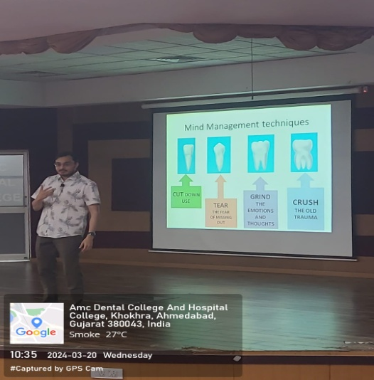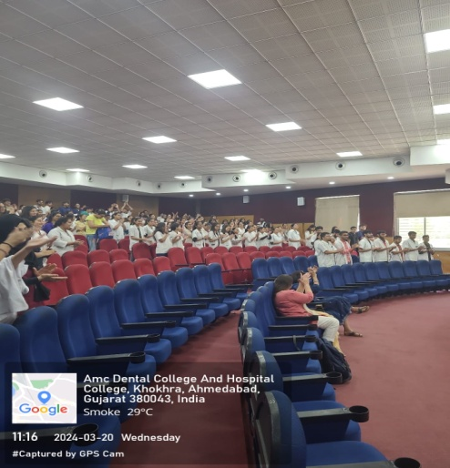

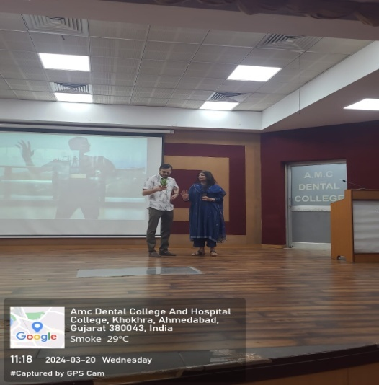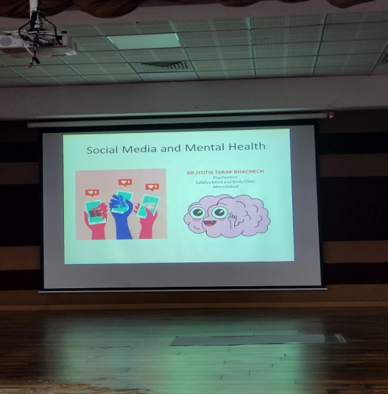

Dr Chirag Rudakia
Program Co ordinator

Dr. Chirag Rudakia
Coordinator
COVER2COVER LITERATURE CLUB
AMC Dental College.
Date: 12/4/2024.

To,
Dr Karan Shah
NHL Medical College
Ahmedabad.

Subject: Invitation to be judge at “OPEN MIC 4.0 EVENT”.

Respected Sir,
This is an invitation for you to be a judge at our OPEN MIC EVENT 4.0. This event is an annual event conducted by COVER2COVER literature club, which is an integral part of AMC DENTAL COLLEGE run by AMCMET.
This event serves as a platform for the students of medical and dental field to showcase their talent in poetry, storytelling, stand up comedy, etc.
We consider it our pleasure to have you as our judge for the event.

Kindly confirm and oblige.

Thanking you.

Yours Respectfully

Dr Chirag Rudakia
Co ordinator
Cover2cover club

Dr. Chirag Rudakia
Coordinator
COVER2COVER LITERATURE CLUB
AMC Dental College.
Date: 12/4/2024.

To,
Dr. Gati Desai
NHL Medical College
Ahmedabad.

Subject: Invitation to be judge at “OPEN MIC 4.0 EVENT”.

Respected Ma’am,
This is an invitation for you to be a judge at our OPEN MIC EVENT 4.0. This event is an annual event conducted by COVER2COVER literature club, which is an integral part of AMC DENTAL COLLEGE run by AMCMET.
This event serves as a platform for the students of medical and dental field to showcase their talent in poetry, storytelling, stand up comedy, etc.
We consider it our pleasure to have you as our judge for the event.

Kindly confirm and oblige.

Thanking you.

Yours Respectfully

Dr Chirag Rudakia
Co ordinator
Cover2cover club

Dr. Chirag Rudakia
Co-ordinator
Cover2Cover Club
Date: 19/4/2024

To
The Dean
AMC Dental College and hospital.
Ahmedabad.

Subject: Permission to conduct “LAUNCHPAD TO DDS” program
on US Education to Indian Dentists
Respected Ma’am,
I , undersigned, kindly request you to grant permission to conduct “LAUNCHPAD TO DDS”- A comprehensive guide to Indian Dentists on 22nd April 2024 from 1:30 p.m. to 2:30 p.m. This program is conducted to provide education and guidance to students and Interns who wish to pursue education in USA in Dental Schools. The program shall be conducted by Dr Mishri parikh, an alumnus of AMC Dental college.
Kindly grant us permission to avail Lecture Hall-1 for the program. I hereby request you to grant permission to students attend the program.
Thanking you.
Yours respectfully

Dr. Chirag Rudakia

